INSTITUTE: TOPS TECHNOLOGIES (BARODA)
NAME: Sappy Bawa
COURSE: Python Full Stack Developer
Module 6 – Fundamentals of Python Language

- Introduction to Python:
Theory:
Q-1) Introduction to Python and its Features (simple, high-level, interpreted language):
A-1) Python is a high-level, interpreted programming language known for its simplicity and readability. Python is an interpreted language, which means the code is executed directly by an interpreter line by line, without needing to be compiled first. This makes the
development process faster and easier to debug. It's also dynamically typed, so you don't have to declare the data type of a variable beforehand. The interpreter automatically determines the type at runtime. Python is highly versatile and supports various
programming paradigms, including object-oriented, procedural, and functional programming.

Q-2) History and evolution of Python:
A-2) Python was created by Guido van Rossum in late 1989 (implementation started in December 1989) at the Centrum Wiskunde & Informatica (CWI) in the Netherlands as a hobby project. The first public version, Python 0.9.0, was released in February 1991. The name "Python" comes from the BBC comedy series Monty Python's Flying Circus.
Python 1.0 was released in January 1994. This version established the foundation of the language with core features such as:
- Exception handling
- Functions and modules
- Basic object-oriented programming (classes with inheritance)
- Functional programming tools like lambda, map, filter, and reduce
Python 1.x made the language practical and usable for scripting and small-to-medium applications, helping it gain initial popularity in the 1990s.

Python 2.0 was released in October 2000. It marked a major growth phase with important additions like:
- List comprehensions
- Cycle-detecting garbage collector
- Unicode support
- A more community-driven development process using Python Enhancement Proposals (PEPs)
The 2.x series (especially Python 2.7) became extremely popular for web development, automation, scientific computing, and general-purpose programming. It powered much of the early internet and data science boom due to its "batteries-included" philosophy and ease of use.

Python 3.0 (also called "Python 3000" or Py3k) was released in December 2008. It was a deliberate, backwards-incompatible redesign to fix long-standing issues in Python 2 and clean up the language (following the principle: "There should be one—and preferably only one—obvious way to do it").
Key improvements in Python 3 include:
- Print became a function
- Unicode strings as default
- Cleaner integer division
- Removal of redundant features
After a long transition period, Python 2 reached end-of-life in 2020. Today, Python 3 (latest stable version: Python 3.14.3 as of early 2026) is the standard and actively developed version. It continues to evolve with better performance, modern features (like type hints, async/await, pattern matching), and a massive ecosystem of libraries, making it dominant in data science, AI, web development, and automation.

Python’s evolution shows its focus on readability, simplicity, and continuous improvement through community involvement.

Q-3) Advantages of using Python over other programming languages:
A-3) Python has become one of the most popular programming languages due to its many advantages:
- Easy to Learn and Read: Python has simple and clean syntax that is very close to English, making it beginner-friendly and easy to understand.
- Less Code: Programs in Python require fewer lines of code compared to languages like C++, Java, or C#.
- Versatile: It is a general-purpose language used in Web Development, Data Science, Artificial Intelligence, Machine Learning, Automation, and more.
- Huge Library Support: Python has a vast collection of ready-made libraries (like NumPy, Pandas, Django, TensorFlow) that save a lot of development time.
- Cross-Platform: Python code can run on Windows, Mac, Linux, and other operating systems without any changes.
- Strong Community: It has a large and active community that provides quick support, tutorials, and regular updates.
- Rapid Development: Developers can build and test applications quickly due to its simplicity and extensive tools.
Because of these advantages, Python is widely preferred by beginners as well as professionals for both learning and real-world projects.
Feature | Python | Java | C++ | R
Ease of Learning | Very easy | Moderate | Hard | Moderate
Use Cases | Web, AI, ML, Data Science | Enterprise, Android | System software, Games | Data Science, Statistics
Community Support | Strong | Strong | Moderate | Strong (academic)
Development Speed | Fast | Moderate | Slow | Moderate
Libraries | Extensive | Extensive | Limited | Specialized (data/statistics)

Q-4) Installing Python and setting up the development environment (Anaconda, PyCharm, or VS Code).
A-4) Install Python: Download the latest version of Python from the official website and run the installer. Make sure to check the box that says "Add Python to PATH" during installation. This allows you to run Python from any command line window.
Now one needs to setup an environment to run Python. Download PyCharm from official website and install it. Once that is done, one can start a project there and follow the necessary steps.

Q-5) Writing and executing your first Python program.
A-5)
Code:
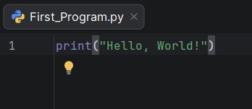
Output:
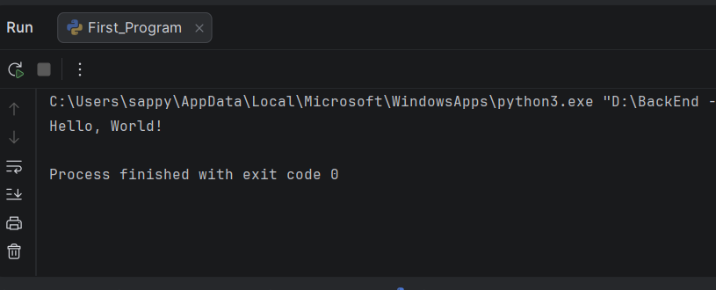
Lab:
Q-6) Write a Python program that prints "Hello, World!".
A-6)
Code:

Output:


Q-7) Set up Python on your local machine and write a program to display your name
A-7)
Code:
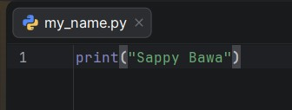
Output:

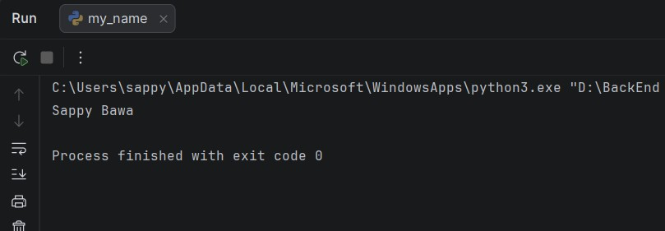

- Programming Style:

Theory:
Q-8) Introduction to Python and its Features (simple, high-level, interpreted language):
A-8) Python is a high-level, interpreted programming language known for its simplicity and readability

PEP 8 is the official Python style guide that defines coding conventions to make Python code more readable, consistent, and maintainable. It covers rules for indentation, naming, spacing, comments, and overall code layout.
What is PEP 8?
- PEP stands for Python Enhancement Proposal.
- PEP 8 is the style guide authored by Guido van Rossum (Python’s creator) and others in 2001.
- It sets the standard coding style for Python’s standard library and is widely adopted by developers worldwide.

Q-9) Indentation, comments, and naming conventions in Python:
A-9) We can look up PEP 8 for the guidelines
Key Guidelines in PEP 8
1. Indentation
- Use 4 spaces per indentation level (not tabs).
- Ensures uniform structure and readability.
2. Line Length
- Limit lines to 79 characters for code and 72 characters for docstrings/comments.
3. Naming Conventions
- Variables & functions: lower_case_with_underscores / snake_cases_with_underscores
- Classes: CapWords (PascalCase)
- Constants: ALL_CAPS_WITH_UNDERSCORES
4. Whitespace Rules
- Add spaces around operators (x = y + 2) but not inside parentheses (func(x, y)).
- Avoid unnecessary blank lines but use them to separate logical sections.
5. Comments & Docstrings
- Use docstrings ("""...""") to describe modules, classes, and functions.
- Write inline comments sparingly and only when necessary.
6. Imports
- Each import on a separate line.
- Standard library imports first, then third-party, then local modules.

Q-10) Writing readable and maintainable code
A-10) Writing readable and maintainable code is crucial for project longevity and collaboration. This means consistently following PEP 8 guidelines for formatting and style, such as using snake_case for variables and functions. You should use meaningful names for variables, functions, and classes to make the code self-documenting.
Additionally, you should write concise, well-documented code by using docstrings to explain complex functions and inline comments to clarify non-obvious logic. Finally, keeping functions small and focused on a single task makes them easier to test, debug, and reuse.
These practices collectively ensure your code is clear, logical, and easy for others—and your future self—to understand.

Lab:
Q-11) Write a Python program that demonstrates the correct use of indentation, comments, and variables following PEP 8 guidelines.
A-11)
Code:
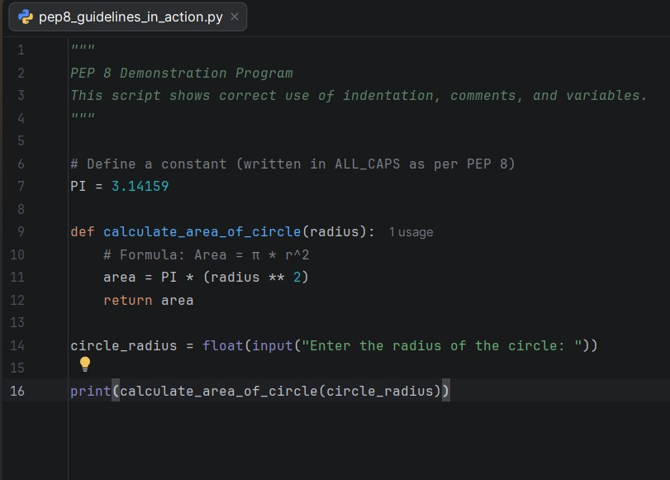

Output:
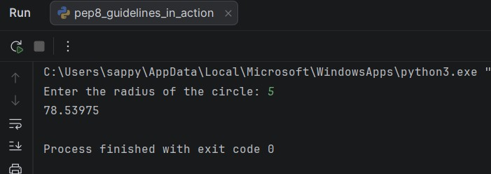

- Core Python Concepts:

Theory:

Q-12) Understanding data types: integers, floats, strings, lists, tuples, dictionaries, sets.
A-12)
1. Integers (int)
- Used to store whole numbers (positive or negative).
- Example: age = 20, marks = -5
2. Floats (float)
- Used to store decimal numbers (numbers with fractional part).
- Example: price = 99.99, PI = 3.14
3. Strings (str)
- Used to store text or sequence of characters.
- Enclosed in single (' ') or double (" ") quotes.
- Example: name = "Sappy", message = 'Hello, World!'
4. Lists (list)
- Ordered, mutable (can be changed) collection of items.
- Items can be of different data types.
- Example: numbers = [10, 20, 30], fruits = ["apple", "banana", "mango"]
5. Tuples (tuple)
- Ordered, immutable (cannot be changed) collection of items.
- Used when data should not be modified.
- Example: coordinates = (10.5, 20.8), colors = ("red", "green", "blue")
6. Dictionaries (dict)
- Unordered collection of key-value pairs.
- Keys must be unique and immutable.
- Example: student = {"name": "Rahul", "age": 21, "city": "Vadodara"}
7. Sets (set)
- Unordered collection of unique items.
- Does not allow duplicate values.
- Example: unique_numbers = {1, 2, 3, 4, 5}

Data Type | Ordered | Mutable | Allows Duplicates | Example
Integer | N/A | N/A | N/A | 10
Float | N/A | N/A | N/A | 3.14
String | Yes | Immutable | Yes | "Hello"
List | Yes | Yes | Yes | [1, 2, 3]
Tuple | Yes | No | Yes | (1, 2, 3)
Dictionary | No | Yes | Keys unique | {"a": 1, "b": 2}
Set | No | Yes | No | {1, 2, 3}

Q-13) Python variable and memory location
A-13)
Variables:
In Python, variables act as references (names) pointing to objects in memory, and memory allocation is handled automatically through mechanisms like reference counting and garbage collection. This means developers don’t manually manage memory.
Do not need to declare a variable or specify its data type before using it. You just assign a value using the = operator. Python is dynamically typed. The data type is automatically determined at runtime based on the value assigned.
Memory Allocation:
When you create a variable, Python automatically allocates memory for it. Variables in Python do not store the actual value directly. Instead, they store a reference (like a pointer) to the object in memory. Every value in Python is an object (integer object, string object, list object, etc.). Python uses automatic memory management (Garbage Collector) to free up memory when an object is no longer needed.

Q-14) Python variable and memory location
A-14)

Operator Type | Symbols | Example | Output
Arithmetic | +, -, *, /, //, %, ** | 5 + 3 | 8
Comparison | ==, !=, >, <, >=, <= | 5 > 3 | True
Logical | and, or, not | (5 > 3 and 2 < 4) | True
Bitwise | &, ^, ~, <<, >> | 5 & 3 | 1

Lab:

Q-15) Write a Python program to demonstrate the creation of variables and different data types.
A-15)
Code:
"""
Program: Demonstrating Variables and Data Types in Python
"""
# Integer
age = 19
print("Age:", age, "Type:", type(age))
# Float
height = 5.9
print("Height:", height, "Type:", type(height))
# String
name = "Sappy"
print("Name:", name, "Type:", type(name))
# List (ordered, mutable)
fruits = ["apple", "banana", "cherry"]
print("Fruits:", fruits, "Type:", type(fruits))
# Tuple (ordered, immutable)
coordinates = (10, 20)
print("Coordinates:", coordinates, "Type:", type(coordinates))
# Dictionary (key-value pairs)
student = {"name": "Sappy", "age": 19, "course": "Python"}
print("Student:", student, "Type:", type(student))
# Set (unordered, unique elements)
unique_numbers = {1, 2, 3, 3}
print("Unique Numbers:", unique_numbers, "Type:", type(unique_numbers))

Output:
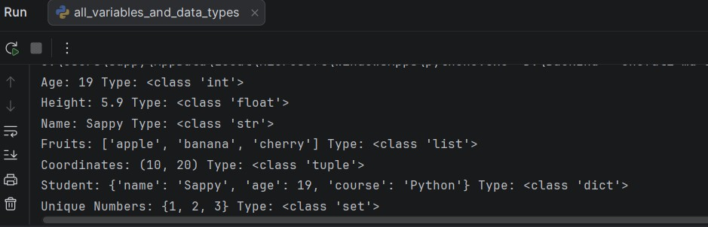

Q-16) Practical Example 1: How does the Python code structure work?
A-16) The Python code structure works through a set of rules governing indentation, code blocks, and the execution flow. Unlike many other languages that use curly braces {} to define code blocks, Python uses indentation.

Q-17) Practical Example 1: How does the Python code structure work?
A-17) The Python code structure goes from Top to Bottom. It works through a set of rules governing indentation, code blocks, and the execution flow. Unlike many other languages that use curly braces {} to define code blocks, Python uses indentation

Q-18) Practical Example 2: How to create variables in Python?
A-18)
Code:
"""
Program: Demonstrating Variables and Data Types in Python
"""
# Integer
age = 19
print("Age:", age, "Type:", type(age))
# Float
height = 5.9
print("Height:", height, "Type:", type(height))
# String
name = "Sappy"
print("Name:", name, "Type:", type(name))
# --- Boolean ---
is_student = True
print("Is Student:", is_student, "Type:", type(is_student))
# List (ordered, mutable)
fruits = ["apple", "banana", "cherry"]
print("Fruits:", fruits, "Type:", type(fruits))
# Tuple (ordered, immutable)
coordinates = (10, 20)
print("Coordinates:", coordinates, "Type:", type(coordinates))
# Dictionary (key-value pairs)
student = {"name": "Sappy", "age": 19, "course": "Python"}
print("Student:", student, "Type:", type(student))
# Set (unordered, unique elements)
unique_numbers = {1, 2, 3, 3}
print("Unique Numbers:", unique_numbers, "Type:", type(unique_numbers))

Output: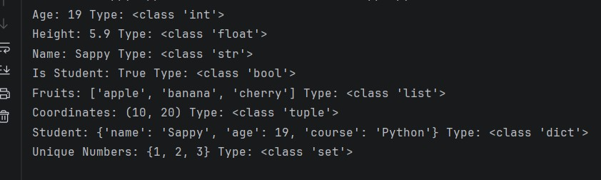

Q-19) Practical Example 3: How to take user input using the input() function
A-19) In Python one can accept user input from the input() function
Code:
str_user = input(“Enter a string:”)
print(str_user)

Output
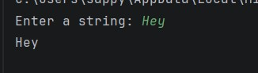

Q-20) Practical Example 4: How to check the type of a variable dynamically using type().
A-20) Python uses type() to check the type of variable
Code:
str_user_name = "Sappy"
print("You entered: ", str_user_name, "which is a type of: ", type(str_user_name))

Output
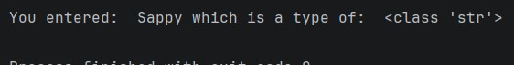

- Conditional Statement:

Theory:

Q-21) Introduction to conditional statements: if, else, elif
A-21) Conditional statements in Python (if, else, elif) allow programs to make decisions by executing different blocks of code depending on whether conditions evaluate to True or False. They are the foundation of control flow in Python.

Example:
if condition1:
# block if condition1 is True
elif condition2:
# block if condition2 is True
else:
# block if none are True

Q-22) Nested if-else conditions
A-22) Nested if-else statements in Python allow you to place one conditional block inside another, enabling multi-level decision-making. They are useful when a condition itself requires further checks before deciding the outcome.
When an if, elif, or else block contains another if, elif, or else statement inside it, it is called Nested if-else.

Example:
if condition1:
if condition2:
# Code block if both condition1 and condition2 are True
else:
# Code block if condition1 is True but condition2 is False
else:
# Code block if condition1 is False

LAB:
Q-23) Practical Example 5: Write a Python program to find greater and less than a number using if_else.
A-23)
Code:
# Taking input from user
num1 = int(input("Enter first number: "))
num2 = int(input("Enter second number: "))
print("\n--- Result ---")
# Using if-else to compare two numbers
if num1 > num2:
print(num1, "is greater than", num2)
print(num2, "is smaller than", num1)
elif num1 < num2:
print(num2, "is greater than", num1)
print(num1, "is smaller than", num2)
else:
print("Both numbers are equal:", num1, "=", num2)

Output:
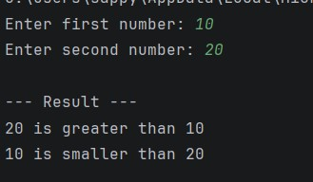

Q-24) Practical Example 6: Write a Python program to check if a number is prime using if_else.
A-24)
Code:
# Taking input from user
number = int(input("Enter a number: "))
count = 0
# Check Prime or not
for i in range(1, number):
if number % i == 0:
count+=1
if count > 2:
print("The number", number, "is not a prime number")
else:
print("The number", number, "is a prime number")

Output:
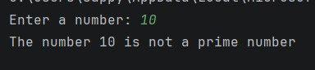

Q-25) Practical Example 7: Write a Python program to calculate grades based on percentage using if-else ladder.
A-25)
Code:
# Input percentage
percentage = float(input("Enter your percentage: "))
# If-else ladder for grade calculation
if percentage >= 90:
print("Grade: A+")
elif percentage >= 80:
print("Grade: A")
elif percentage >= 70:
print("Grade: B")
elif percentage >= 60:
print("Grade: C")
elif percentage >= 50:
print("Grade: D")
else:
print("Grade: F (Fail)")

Output:
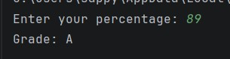

Q-26) Practical Example 8: Write a Python program to check if a person is eligible to donate blood using a nested if.
A-26)
Code:
"""
Program: Blood Donation Eligibility Checker
Demonstrates nested if-else conditions in Python.
"""

# Input details
age = int(input("Enter your age: "))
weight = float(input("Enter your weight (in kg): "))

# Outer condition: check age
if age >= 18:
# Inner condition: check weight
if weight >= 50:
print("You are eligible to donate blood.")
else:
print("You are not eligible to donate blood (weight must be at least 50 kg).")
else:
print("You are not eligible to donate blood (age must be at least 18).")

Output:
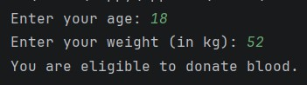

- Looping (for, while):

Theory:
Q-26) Introduction to for and while loops
A-26) Loops are used in Python to execute a block of code repeatedly until a certain condition is met. Python provides two main types of loops: for loop and while loop.
For Loop:
- Used when we know how many times the loop should run.
- Mostly used to iterate over a sequence (list, tuple, string, range, etc.).
Syntax:
for variable in sequence:
# code to repeat

While Loop:
- Used when we don’t know how many times the loop should run.
- The loop continues as long as the given condition is True.
Syntax:
while condition:
# code to repeat

Q-27) How loops work in Python.
A-27) Loops in Python are control structures that allow repeated execution of a block of code until a condition is met or a sequence is exhausted. They reduce redundancy and make programs more efficient.
Python has two main types of loops: for loop and while loop.

Q-28) Using loops with collections (lists, tuples, etc.).
A-28)
Lists:
fruits = ["apple", "banana", "cherry"]
for fruit in fruits:
print(fruit)

Tuples:
coordinates = (10, 20, 30)
for point in coordinates:
print(point)

Sets:
unique_numbers = {1, 2, 3, 4}
for num in unique_numbers:
print(num)

Dictionaries:

student = {"name": "Sappy", "age": 19, "course": "Python"}

# Loop through keys
for key in student:
print(key, ":", student[key])

# Loop through items
for key, value in student.items():
print(key, "->", value)

Lab:

Q-29) Practical Example 1: Write a Python program to print each fruit in a list using a simple for loop. List1 = ['apple', 'banana', 'mango']
A-29)
Code:
"""Practical Example 1: Write a Python program to print each fruit in a list using a simple for loop.
List1 = ['apple', 'banana', 'mango']"""
List1 = ['apple', 'banana', 'mango']
for fruit in List1:
print(fruit)

Output:
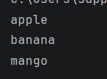
Q-30) Practical Example 2: Write a Python program to find the length of each string in List1.
A-30)
Code:
"""Q-30) Practical Example 2: Write a Python program to find the length of each string in List1."""
List1 = ['apple', 'banana', 'mango']
for string in List1:
print(string, ":", len(string))

Output:
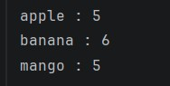

Q-31) Practical Example 3: Write a Python program to find a specific string in the list using a simple for loop and if condition
A-31)
Code:
"""Practical Example 3: Write a Python program to find a specific string in the list
using a simple for loop and if condition"""
fruits_list = ['apple', 'banana', 'mango', 'orange']
fruit_search = input("Enter a fruit to search for: ")
found = False
for fruit in fruits_list:
if fruit == fruit_search:
print(fruit_search, "is in the list")
found = True
break
if not found:
print(fruit_search, "The fruit is not in the list")
print()
print("The complete fruit list is: ", fruits_list)

Output:
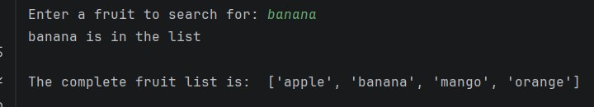

Q-31) Practical Example 4: Print this pattern using nested for loop:
*
**
***
****
*****
A-31)
Code:
"""Practical Example 4: Print this pattern using nested for loop: """
number = 6
for i in range(1,number):
for j in range(i):
print("*", end=" ")
print()

Output:
